Available online at [www.sciencedirect.com](http://www.sciencedirect.com/)



AASRI Procedia 3 (2012) 721 – 726

# 2012 AASRI Conference on Modeling, Identification and Control

Soot Concentration Measurement System of the Stationary Pollution Source Using the Scattering-Transmission Method

Yanjun Zhao*, Meng Fanwei, Qu Bin

*College of Electrical Engineering, Hebei United University, No. 46, Xinhua West Road, Tangshan 063009, China*

**Abstract**

The soot emitted from the stationary pollution source is one of the important atmospheric pollutants. The soot concentration is an important influence and can detect the total emissions condition of the pollution source. The new on-line Scattering-Transmission soot concentration measurement method is presented. The new method is based on the Scattering integration method and the Extinction theory. The measurement result of the new method is independent of the soot size distribution and the soot average size. The numerical simulation results based on Mie scattering theory confirmed the validity of the techniques. The measurement instrument based on this method is produced. The instrument is produced. The system uses 80C252 as the MCU, displays measurement result through LCD and transfers the measurement to the monitoring computer. Soot concentration measurement system is calibrated in one of the steel mill. The results showed the method is very reliable, high precision.

© 2012 The Authors. Published by Elsevier B.V. Open access under [CC BY-NC-ND license.](http://creativecommons.org/licenses/by-nc-nd/3.0/)

© 2012 Published by Elsevier B.V. Selection and/or peer review [under responsi](http://creativecommons.org/licenses/by-nc-nd/3.0/)bility of American Applied Science Research Institute

Selection and/or peer review under responsibility of American Applied Science Research Institute

*Keywords:* Cheating detection; Analysis; Truck position; Voltage waveform; Truck scale

## Main text

With the rapid development of world industrialization, the world environment pollution problem is increasingly serious. The exhaust dust of the coal-fire boilers is one of the uppermost sources of the air dust

* Corresponding author. Tel.: +0-188-0315-3322.

*E-mail address:* [zhyj_ts@sohu.com.](mailto:zhyj_ts@sohu.com)

2212-6716 © 2012 The Authors. Published by Elsevier B.V. Open access under [CC BY-NC-ND license.](http://creativecommons.org/licenses/by-nc-nd/3.0/) Selection and/or peer review under responsibility of American Applied Science Research Institute doi:10.1016/j.aasri.2012.11.114

pollution[1]. The on-line, continuous measurement of the soot concentration has the increasingly importance to prevent effectively atmosphere pollution. To obtain the soot emission, soot concentration has to be measured in real time. So it is highly desirable to develop an automatic continuous instrument that is suitable for the measurement of the soot concentration[2].

The common methods of measuring the soot concentration are the ISO-Kinetic Sampling techniques and the Extinction. The principle of the ISO-Kinetic Sampling is briefness, but its disadvantages are that its result is not credibility enough and cannot carry through continuous measurement. The Extinction principle is based on the Lambert-Beer Law. The concentration figured out from the Extinction is related to the average extinction efficiency and the average diameter. The former can be calculated by the Mie theory and considered as the approximated 2[3]. The average diameter is a variable parameter. It must be measured on- line for determining exact concentration of soot in the dust[4].

A new Scattering-Transmission method on measuring soot concentration based on the Scattering integration method and the extinction theory of soot concentration is presented in this paper. Compared with Extinction method, it need not know the soot average diameter in the dust flow in advance. The soot concentration measurement instrument is developed and the experiment is carried out.

## Principle and numerical simulation of the Scattering-Transmission method

Scattering integration method of soot concentration can be expressed by the following equation[5]:

*C * *VP*

*V*

*sAL*

4 2 *I* d 

*ksAL* 0 0



*I*

*K* 2 *I* d 

0 *I* 0



*(1)*

Where CV is the soot’s volume concentration, Vp is the sampling area, S is the light length, Al is the section area of the laser,  is scattering angle, K=2 / , I(  ) is the forward scattered light intensity at  .

The formula of Extinction theory of soot concentration is:

*It * *I*0 exp



ext *s*

*(2)*

Where It is the extinction light intensity, I0 is the incidence light intensity, ext the average extinction coefficient, S is the path length of the light in the medium.

The denominator of the Scattering Integration method equation is I0, so the sensitivity is not very high. If the denominator changes to the extinction light intensity, the sensitivity should be increased. Considered that the incidence light intensity is unchanged and its volume is large enough; comparing to the increase of soot concentration, the extinction light intensity decrease gradually. If the soot is sparse, I0 is regarded as the constant. Then replacing I0 with It, we can obtain a new formula—Scattering-Transmission method.

2

*I* ()*d *

2

*I* ()*d *



*C * *K*  0

*K*  0

*(3)*

*V* exp



*I*

0

ext *s*

# 1 exp

ext *s*

The scattering-transmission method is simulated based on the Mie theory. We assume that the incidence

light wavelength is 0.67  m and the range of the measuring angle is 0 ~ 5 . The different average diameter

can be obtained by adjusting the particles diameter distribution function and the largest diameter. The

different index of 1.80 and 1.57-0.56i is considered because the Mie scattering calculation is related to the refractive index m of the soot. Three types of the soot diameter distribution based on Johnson_SB function are chosen and their distribution parameters are  =2.5  =-2.0   =3.8  =2.0   =4.8  =0.0.

Fig. 1 and Fig. 2 show the numerical simulation result of the difference index m. Fig. 3 and Fig. 4 show the numerical simulation result of the difference diameter distribution.

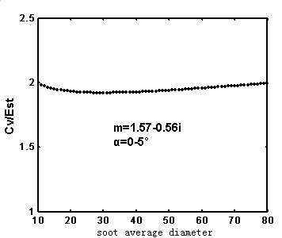

Fig.1 Numerical Simulation1 of the different m

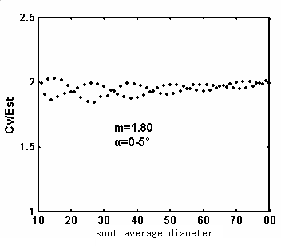

Fig.2 Numerical Simulation1 of the different m.

From the Fig 1 to 2, the measurement coefficient can be approximated as a constant, that is to say the soot concentration measurement result is independence of the soot average diameter. From the Fig 3 to 4, the measurement coefficient can be approximated as a constant, that is to say the soot concentration measurement result is independence of the soot diameter distribution.

## The measurement system

* 1. *The optical path of the measurement system*

The optical system principle of the measurement system is shown in Fig. 5.

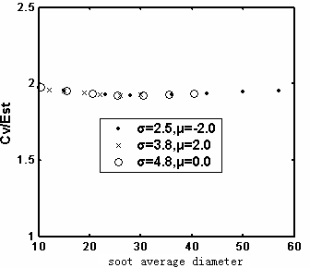

Fig.3 Numerical Simulation1 of the different diameter distribution. m=1.57-0.56i.

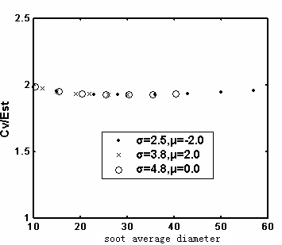

Fig.4 Numerical Simulation1 of the different diameter distribution. m=1.80.



Fig 5 principle of the optical measurement system

The laser 1 is located on the focus of the collimator Lenses 2 and the laser beam is changed into the parallel light. The parallel light beam is divided into two beams through the splitter prism 5. The reflection light is focusing on the photodiode 3 OPT101 through the focus lens 4. The optical signal is converted into the current signal *I*0 as the original light intensity. The transmission beam is across the soot space 6. The

transmission beam is scattering by the soot in the duct and becomes a beam of the composite light composed of the transmission light and the scattering light with the soot concentration information. Passing through the focus lens 7 and the splitter mirror 9, the composite light beam is divided into two beams: one light beam is focusing on the photocell 8 and the other beam is focusing on the photodiode 8 OPT101. The two optical

signals are converted into the current signal *I*1 and *I*2 respectively. The light sensitivity area of the photocell is larger than the photodiode OPT101, so the measurement signal of the photocell is a composite of luminous flux included the transmission light and the large angle scattering light. There has a set of pinhole filter before

the photodiode. The measurement signal *I*2 of the photodiode is included the transmission light and the small angle scattering light. The difference of the photocell light signal *I*1 and the photodiode signal *I*2 is a certain angles of scattering light intensity signal.

Photoelectricity conversion components are an important part of the soot concentration measurement system. According to the principle of the soot concentration measurement system, the measurement system chose two types of optical device: photodiode and the photocell.

The photodiode selects the OPT101 chip produced by BB Corporation. The sensitivity area of OPT101 is

0.09 inch *0.09 inch. OPT101 is combined the amplifier with the photodiode, so it can be effectively eliminate the leakage current and decrease the noise interference.

The measurement range of the photocell is larger, the system chooses the photocell produced by Hamamatsu Corporation which sensitivity area is 10mm*10mm.

* 1. *Hardware design*

Because of the scattering light is very weak, the current signal produced by photodiode and the photocell is very weak. So the signal must be enlarged. The system chooses the LM358 as the amplifier.

The hardware structure of the soot concentration measurement system is shown in Figure 6. The MCU of the voltage waveform detection system is 89C2052, the analog-to-digital conversion chip is ADC0809, the communication chip is MAX232, the watchdog chip is X25045[5-7]. The output voltage signal of the weighing sensors is enlarged by the amplifier circuit and changed into the digital signal by ADC0809. The MCU collects a plurality of sensor output voltage signal simultaneously and sends the measurement data to the monitoring system through the MAX232.



**ADC0809**

**MCU 89C2051**

**X25045**

**MAX232**

**Upper Computer**

**Amplifier circuit**

**Power**

**Sensor**

Figure 6 hardware structure of the output voltage signal detection system

* 1. *Software design*

The SCM software uses KeilVersion2 development platform and uses the modular design method. The software of the detection system includes the analog-to-digital conversion, the signal filtering and the data transmission subroutine. The SCM software flow chat is shown in Figure 7.



Figure 7 SCM software flow chat

## Conclusion

A novel technique, the Scattering-Transmission method, for measuring soot concentration based on the Scattering integration method and the Extinction theory, has been developed. The new technique need not pre-required knowledge about the soot average diameter and the soot diameter distribution. Numerical simulation by using the Mie theory has also infirmed the validity of this technique. Based on the method, a soot concentration measurement system has been developed. The measurement system uses the 89C2052 as the MCU and can transfer the on-line measurement data to the monitoring computer. The measurement system is installed in an exhaust dust of an industrial duct. The experiment results that the Scattering- Transmission method can on-line measuring the soot concentration.

## Reference

1. Zhengran Yu, Application technologies of gas measurement, China environment science Press,1990
2. Ning Mu, Continuous measurement of soot concentration in the exhaust duct, Southeast University, 2004.3
3. Juliuse B. Gajewski, Non-instrusive solids charge and mass flow measurements with an electrostatic flow Probe, Journal of Electrostatics,46,pp317-330,1999
4. Dick V.P., Applicability limits of Beer’s law for disperse media with a high concentration of particles, Applied Optics,37,pp1998- 5004,1998
5. Ye Mao, Light Scattering Methods for In-situ Measuring Soot Size distrinbution and concentration in two-phase flow, D., Southeast University, China, 2000e